**Proof of Equivalence of “Surface Water” and “Ground Water” Mass Balance Equations**

In surface water modeling, if one is interested in the dissolved concentration, it is common to multiply the total concentration times the fraction dissolved, Fd, where Fd is the ratio of the dissolved chemical mass to the total chemical mass. Thus, Cd is related to CT, including a porosity-correction, as

 (1)

By definition, CT is

 (2)

where Cs is the sorbed concentration with units of mass of chemical per mass of solids (Mc/Ms). Substituting (2) into (1), Fd can be expressed as

 (3)

Now, at instantaneous liquid/solids sorption equilibrium (which the standard groundwater PDE equation assumes), Cs and Cd are related as

 (4)

where Kd is the well-known equilibrium partitioning coefficient (Lw3/Ms). Substituting from (3) into (2), Fd can be written as

 (5)

which, after a minor rearrangement of equation , can be seen to be identically 1/R. Therefore, from (4) and (1), Cd can be written as

 (6)

Substituting for Cd from (6) into , and treating R and θ as time and space constants gives

 (7)

Cancelling the common Rθ term and recognizing that the remaining R is implicitly 1.0, because partitioning is moot when modeling total concentration, leaves identically equation , the standard surface water PDE. The result shows that the “surface water” parameter, Fd, and the ground water parameter, R, are simply the inverse of each other.

**Appendix B. Conversion of the GEM PDE to Represent the Chow et al. (1988) Nonlinear, Combined Continuity and Momentum Equation**

Re-expressing the Chow et al. equation (16), repeated here:

 (B-1)

in a GEM-like format (using R) gives

 (B-2a)

where

 (B-2b)

Using a FTBS approach, the GEM mass balance equation (4) can be written in 1-D as

 (B-3)

where no sources/sinks are included, the compartments’ geometry (volume, area) are assumed to be static in time, and

Wit = an external loading to compartment i at time t with units of M/T

 = interfacial flow volume (L3/T) between compartments i and j. (Signs on flows are explicitly included in equation (19)).

 = interfacial area (L2) between compartments i and j

= volume of compartment i (L3)

Ei,j = dispersion coefficient (L2/T) between compartments i and j

Li,j = length over which dispersive mixing occurs between compartments i and j (L)

Θi = water content (L3/L3) of medium

A note about  in equation (B-3) versus “Q” in equation (4) is in order. Q (and A) are SVs of the kinematic wave equation. Their solution in space and time is to be determined.  (and and ) in the GEM equation (4) are parameters of the equation. Their values are assumed to be known. We are trying to parameterize ,, and  in equation (18) in such a way that, along with other changes, the GEM compartment equation (B-3) becomes equivalent to Chow’s finite difference equation (B-1). The overbars on ,, and in equation (B-3) are being used here to remind the reader of that difference. That is, Q, A, and V will refer to the true SV while ,, and will remain simply GEM parameters.

To configure the GEM compartment equation (B-1) to represent the FTBS numerical representation of the kinetic wave partial differential equation (16), we assign:

Ei,j = 0

Θi = 1

Assume the GEM geometry parameters, and , do not change along the modeled length or with time. Also, assign = , i.e. the GEM’s flow parameter is normalized to equal the cross-sectional area. (The flow velocity is then unity.)

Substitute Δx for volume,, and assign = 1.

With these assignments, equation (B-3) becomes



which, after dividing through by Δx is:

 (B-4a)

where,  (B-4b)

If one makes a simple change-of-variables in (B-4) such that the GEM SV “Cd” is identically equal to the kinematic wave SV, Q, comparing the GEM equation (B-4) with the FTBS finite difference equation for the kinetic wave equation (B-2), shows that they are essentially identical. The only exception is the trivial difference that the distributed inflow term, , is based on an average inflow over time steps t and t+1, while our distributed “inflow” term  occurs all within the current time step t. The GEM policy is for time step “t+1” to represent the first instant of the upcoming time step, not sometime *within* (e.g., midpoint) t+1. With this definition, the GEM inflow parameter makes sense.

A note on units is useful. The GEM assumes lengths are in meters, mass in grams, time in days, etc. and the GEM input files contain these default units in the header records. However, no unit conversions are performed anywhere in the GEM code. Therefore, the user may populate the input files using whatever units they desire, so long as the units are internally consistent in the resulting equations. For example, the Chow et al. example uses feet and seconds instead of meters and days. In this application, we simply used the same units in the GEM files as Chow et al.

***Appendix C. Equivalency of 1 SV versus 2 SV models for Soil Medium of Multi-media Example***

We include here a demonstration of the equivalency of the 1 SV (dissolved) versus 2 SV (dissolved, sorbed) approach. The motivation for this analysis is emphasize the flexibility of alternative modeling designs as well as the flexibility of the GEM. In addition, we give an illustration of an instantaneous sorption equilibrium approach (“Kd method”) versus a dynamic sorption approach (ks and kds approach). In this side analysis, only the soil compartments are considered, i.e. compartments 1 – 25. Compartments 1 and 12 are upper boundary compartments. Compartments 13 and 24 serve here as lower boundary compartments, and compartment 25 is a dummy compartment – to receive runoff flows from compartment 14. Volatilization of dissolved chemical to the atmosphere is included, but feedback deposition from the atmosphere (wet and dry deposition) are not included (because the air compartments are not being simulated). For the 2 SV model, the two equations are given by equations 18a and 18b, omitting the vvd vapor deposition source term. In these equations R is understood to be 1.0 (Kd = 0).

For the 1 SV model (dissolved concentration), the mass balance equation is given by equation 18a, omitting the vvd, kds, and ks terms. R is determined as  and Kd is not equal to zero.

We ran both models for the strongly sorbing chemical 1 (see Table 1 for Model 1’s Kd and Model 2’s ks / kds ratio). For the 1 SV model, the initial dissolved concentration in compartment 2 was 100 g/m3 representing a spill of some aqueous waste. For the 2 SV model, the same initial condition for Cd was used. For Cs, an initial condition of 900 g/m3 was used, reflecting the sorbed fraction (at equilibrium) corresponding to the initial Cd concentration (see Table 1). For the 2 SV model, the ks and kds values were assigned in accordance with the ks/kds ratio shown in Table 1, and with an assumed value for kds of 0.1/day (ks = 0.9/day). These 1st order rate constants are reasonably “fast”, e.g. an 0.1/day rate constant can be interpreted as a process affecting approximately 10% of the total chemical mass per day (Chapra, 1997), but would still not represent “instantaneous” equilibrium as implicit in the 1 SV model. We ran the models for 1000 days and the time series results from the two models for Cd in the top and bottom compartments are shown in Figure C-1 for the farm field column and the buffer column.

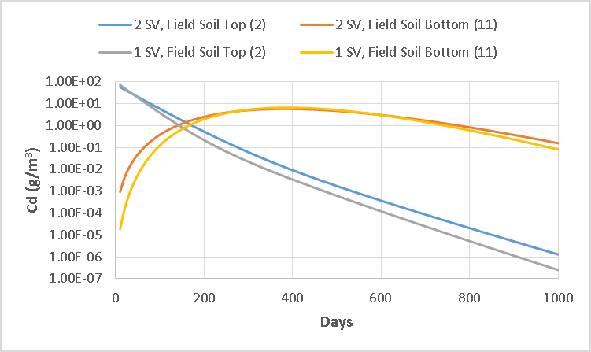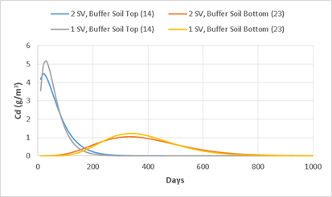

**Figure C-1. Dissolved Concentrations for 2 SV Versus 1 SV Models for Top and Bottom Field and Buffer Compartments**

We see several phenomena in the figures. First, the comparison between top and bottom compartments in both figures shows the downward movement of the chemical due to transport over the 1,000 days. Peak concentration in the field’s top compartment is at time 0 (the spill) while the peak concentration at the bottom compartment occurs at approximately 400 days. Peak concentration in the buffer top compartment is at approximately 30 days, as the runoff from compartment 2 transports chemical into compartment 14. The concentrations in the buffer compartments are also reduced significantly from those in the field compartments due to spatial dilution of the mass and loss due to volatilization.

Regarding the instantaneous (1 SV model) versus dynamic sorption (2 SV model) assumptions, results of the two models are quite similar but with some differences due to slight non-instantaneous equilibrium conditions in the 2 SV model at our specified ks and kds absolute values. A final run of the 2 SV model was made increasing both these values an order of magnitude, and the results are essentially identical to those of the instantaneous equilibrium model, thus showing the equivalence potential of these two approaches. The advantage of the instantaneous equilibrium approach is parsimony in the number of SVs modeled while the advantage of the dynamic sorption approach is maximum flexibility.